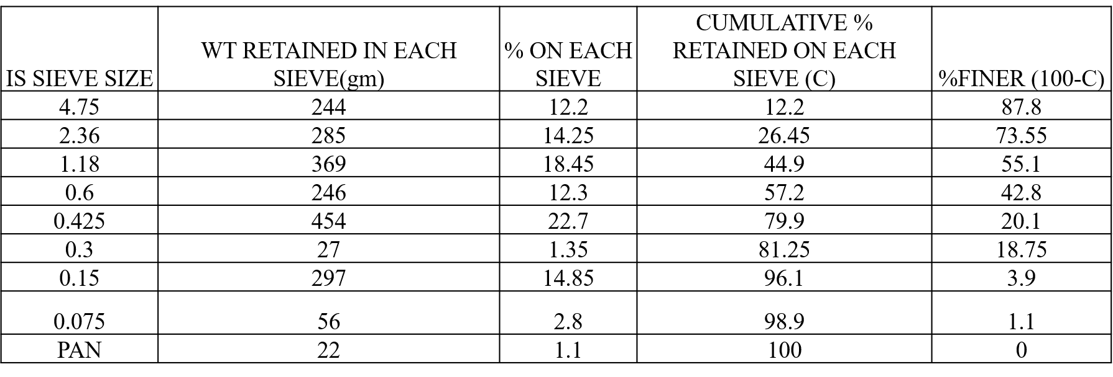

PARTICAL SIZE DISTRIBITION TEST



Coefficient of uniformity=D60/D10=6.82

Coefficient of curvature =D30^2/D10*D30=2.07

% of boulders=100-87.8=12.2

% of cobbles=87.8-73.55=14.25

% of c gravel=73.55-55.1=18.45

% of F gravel=55.1-42.8=12.3

% of C sand=42.8-20.1=22.7

% of Medium sand=20.1-18.75=1.35

% of fine sand=18.75-3.9=14.85

% of silt=3.9-1.1=2.8

% of clay=1.1-0=1.1

Based on the particle size analysis the soil is classified as

Cu=6.82>6

Cc=2.07,1to 3

Therefore the given soil is well graded Soil

From graph

D10=0.17

D30=0.64

D60=1.16

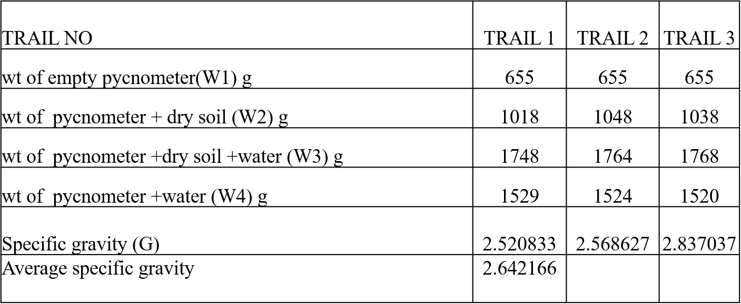

**SPECIFIC GRAVITY TEST BY PYCNOMETER**

RESULT: The specific gravity of given soil= 2.7

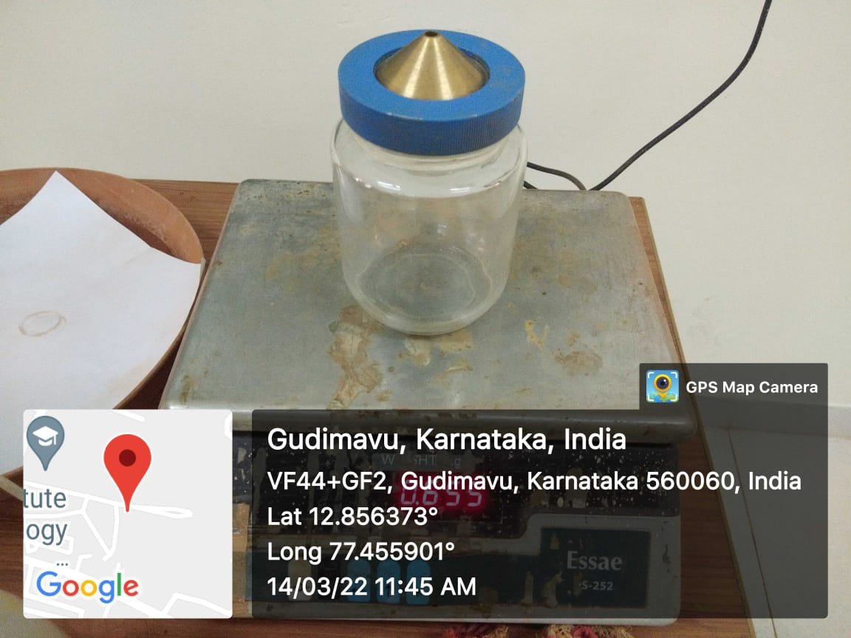

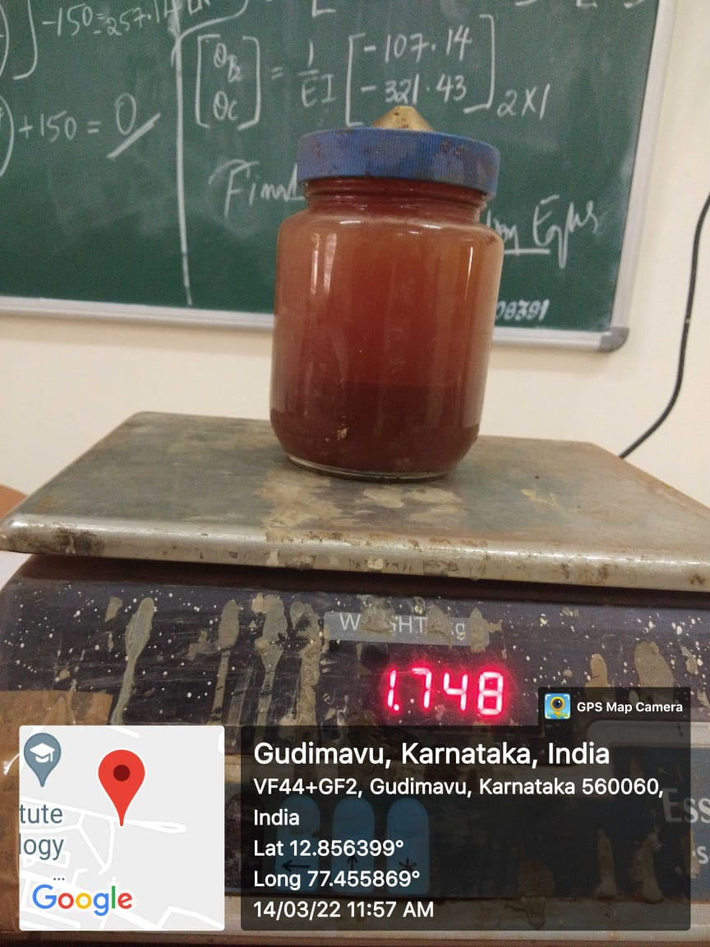



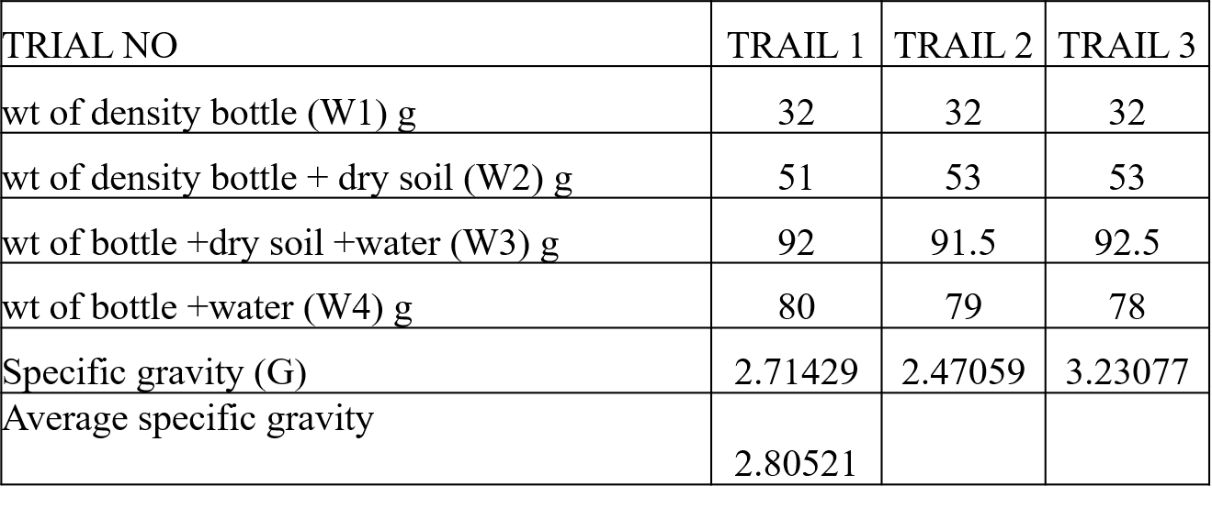

RESULT: specific gravity of soil by pycnometer method – 2.8

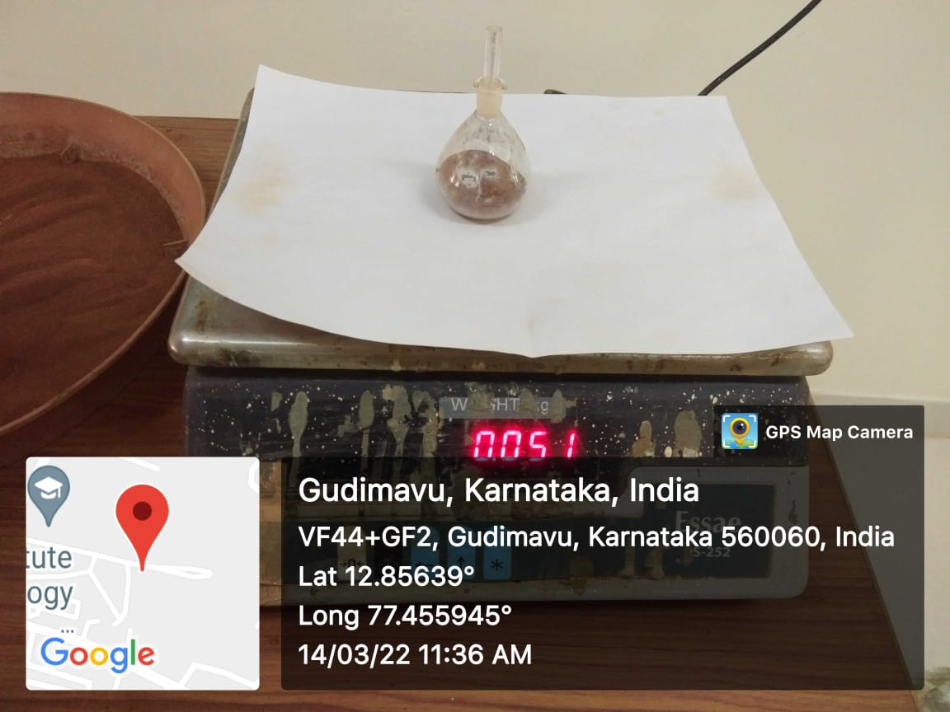 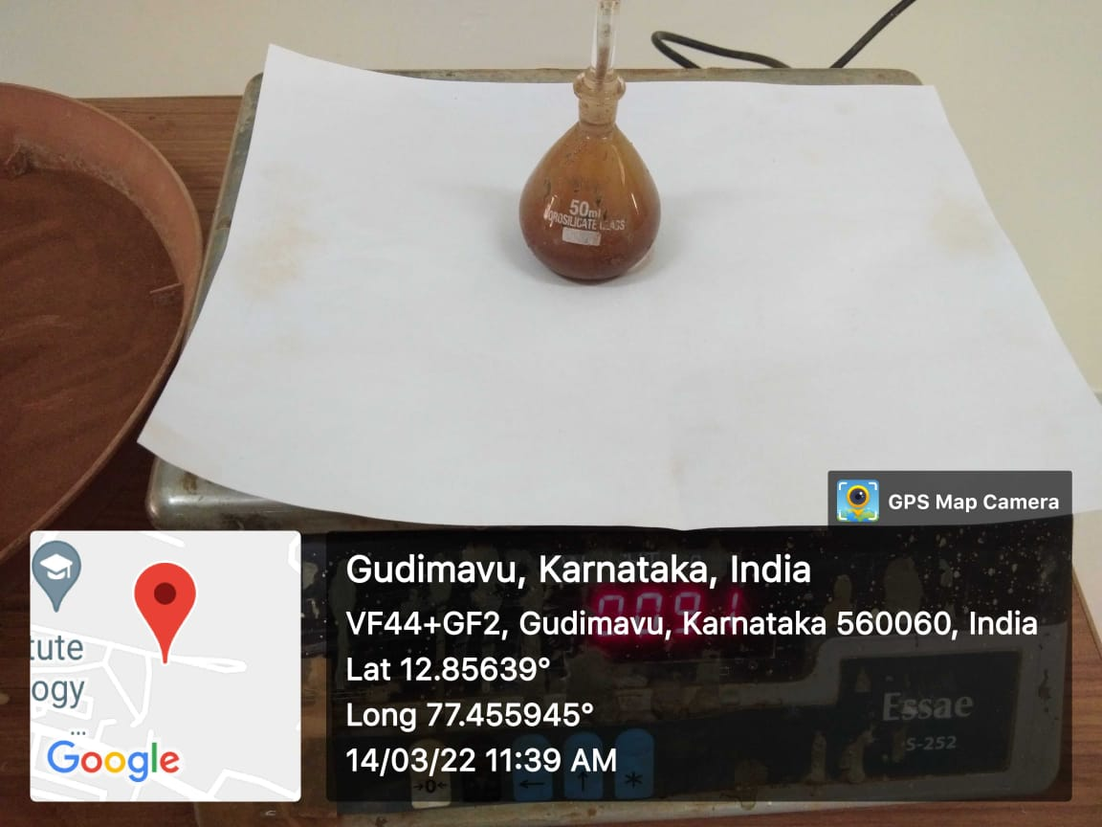

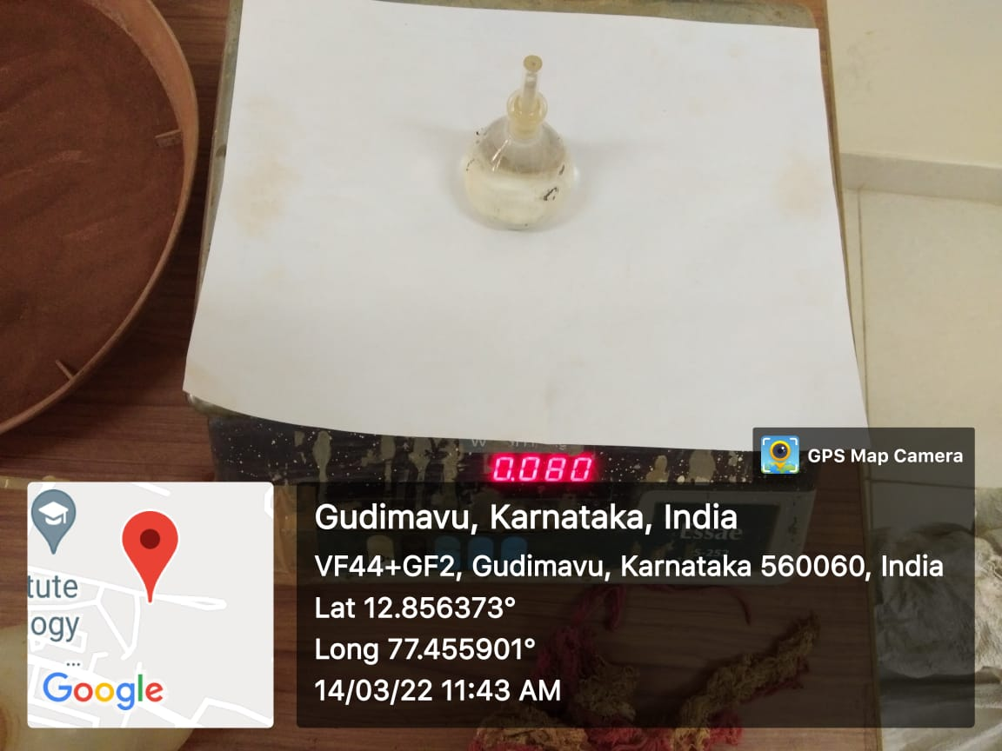

LIQUID LIMIT TEST



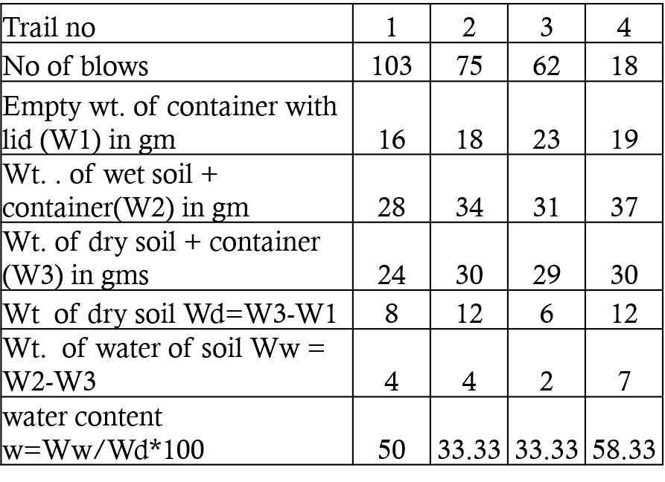

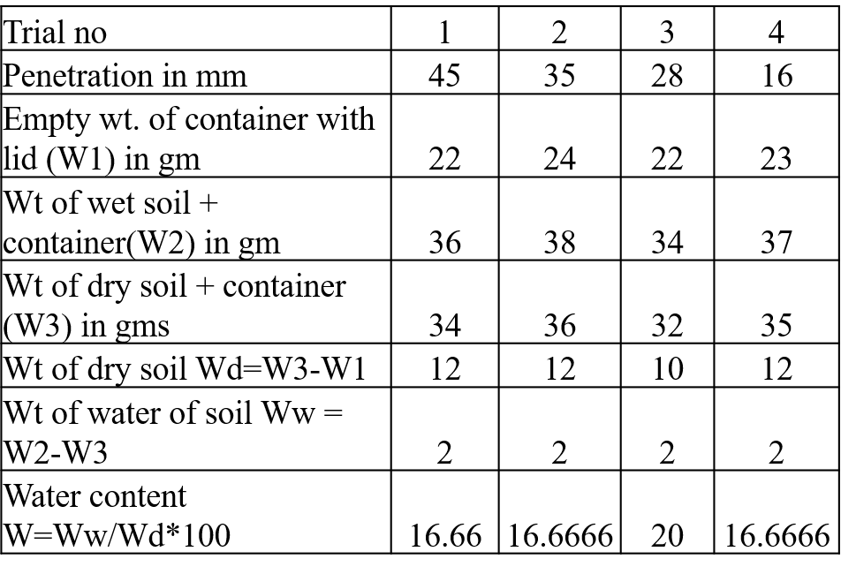

CONE PENETRATION METHOD

CALCULATION

Flow index=If=W1-W2/log10(N2/N1)

=70-22/log10(100/10)

If=48%



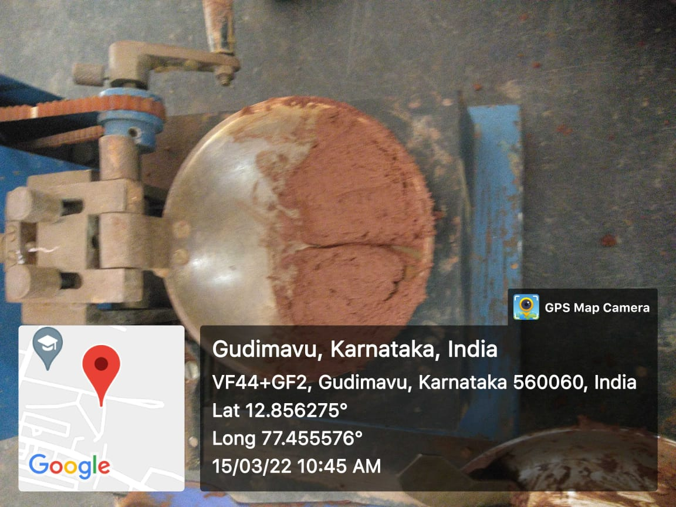

Liquid limit by casagrande method

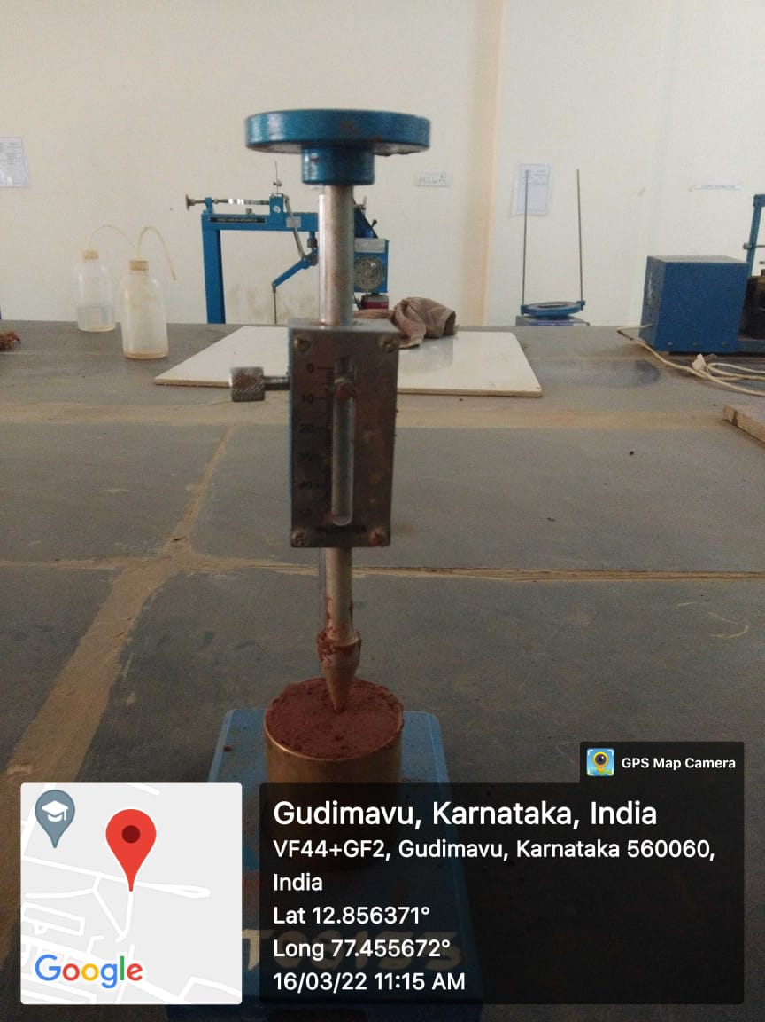

Liquid limit by cone penetration method

PLASTIC LIMIT TEST

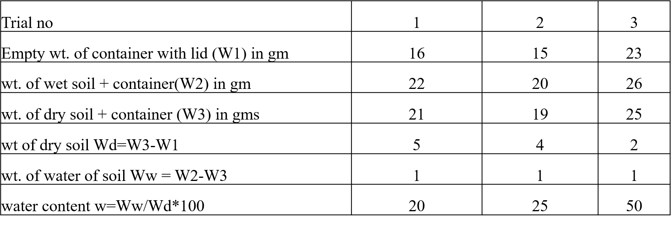

Average plastic limit (Wp)=31.7%

WL=50%

Plasticity index(Ip)=(WL-WP)

=(50-31.7)

=17.3

Toughness index=Ip/If=17.3/48=1( toughness value0-3)



Plastic limit

**STANDARD PROCTOR COMPACTION TEST**

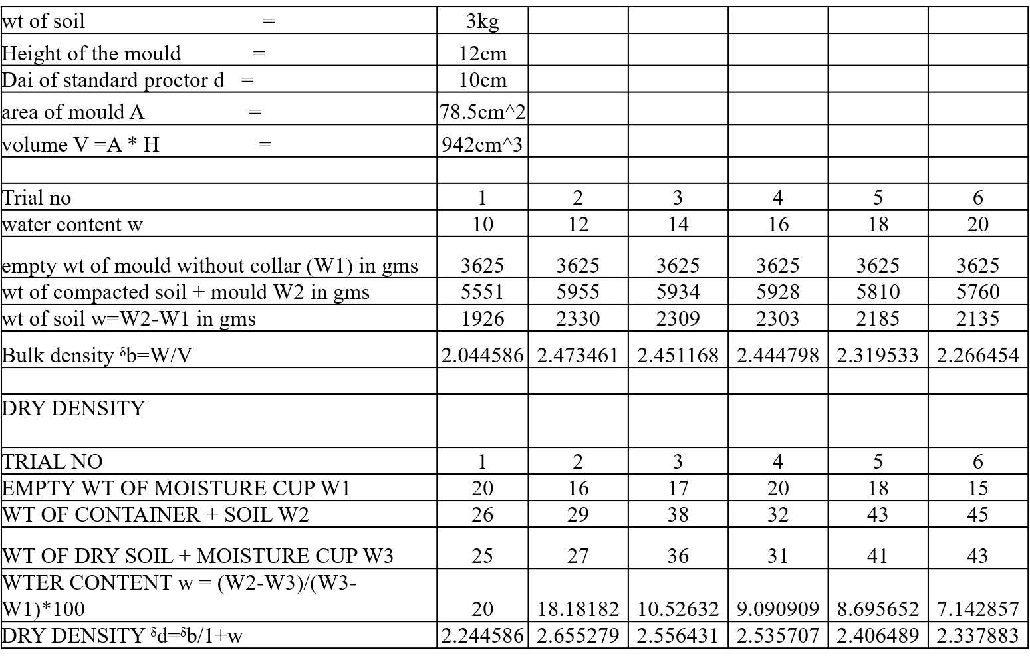

**STANDARD PROCTOR TEST GRAPH**

RESULT: OPTIMUM MOISTURE CONTENT=12.5%

MAXIMUM DRY DENSITY=2.65g/cc

Soil -coir=3000-0.05

Coir=5%=0.05grams

Soil=2950grams

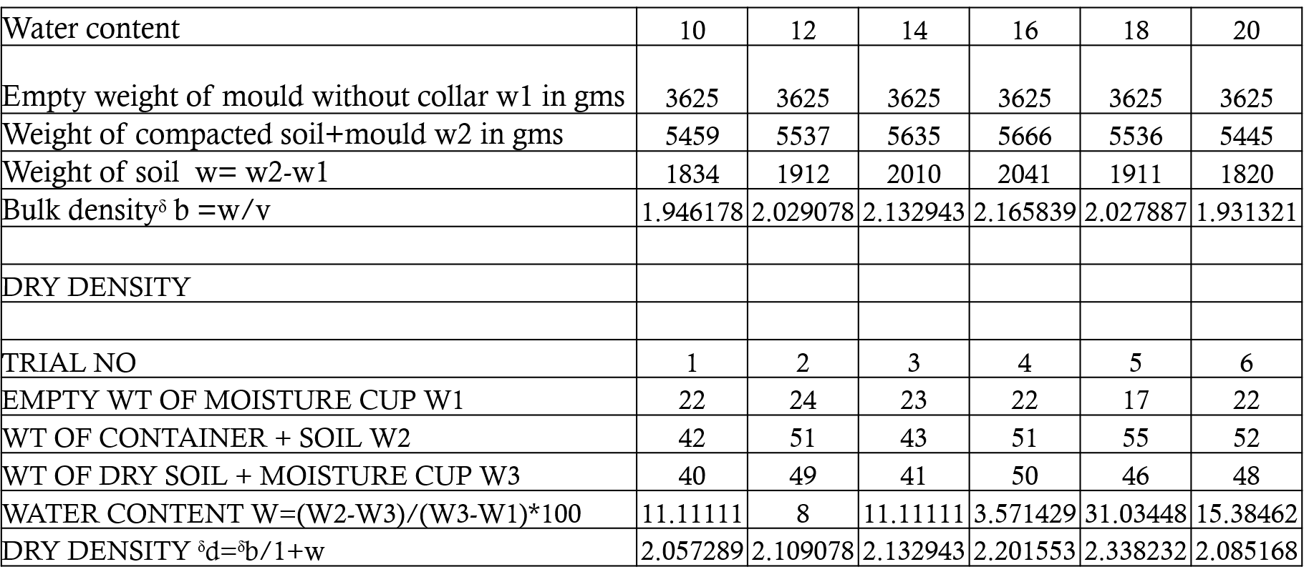

RESULT: OPTIMUM MOSITURE CONTENT=16.2%

MAXIMUM DRY DENSITY=2.33g/cc

Soil -coir=3000-0.05

Coir=5%=0.05grams

Soil=2950grams



Result : optimum moisture content=18%

maximum dry density =2.34g/cc

Soil -coir=3000-0.075

Coir=7.5% =0.075grams

Soil=2925grams

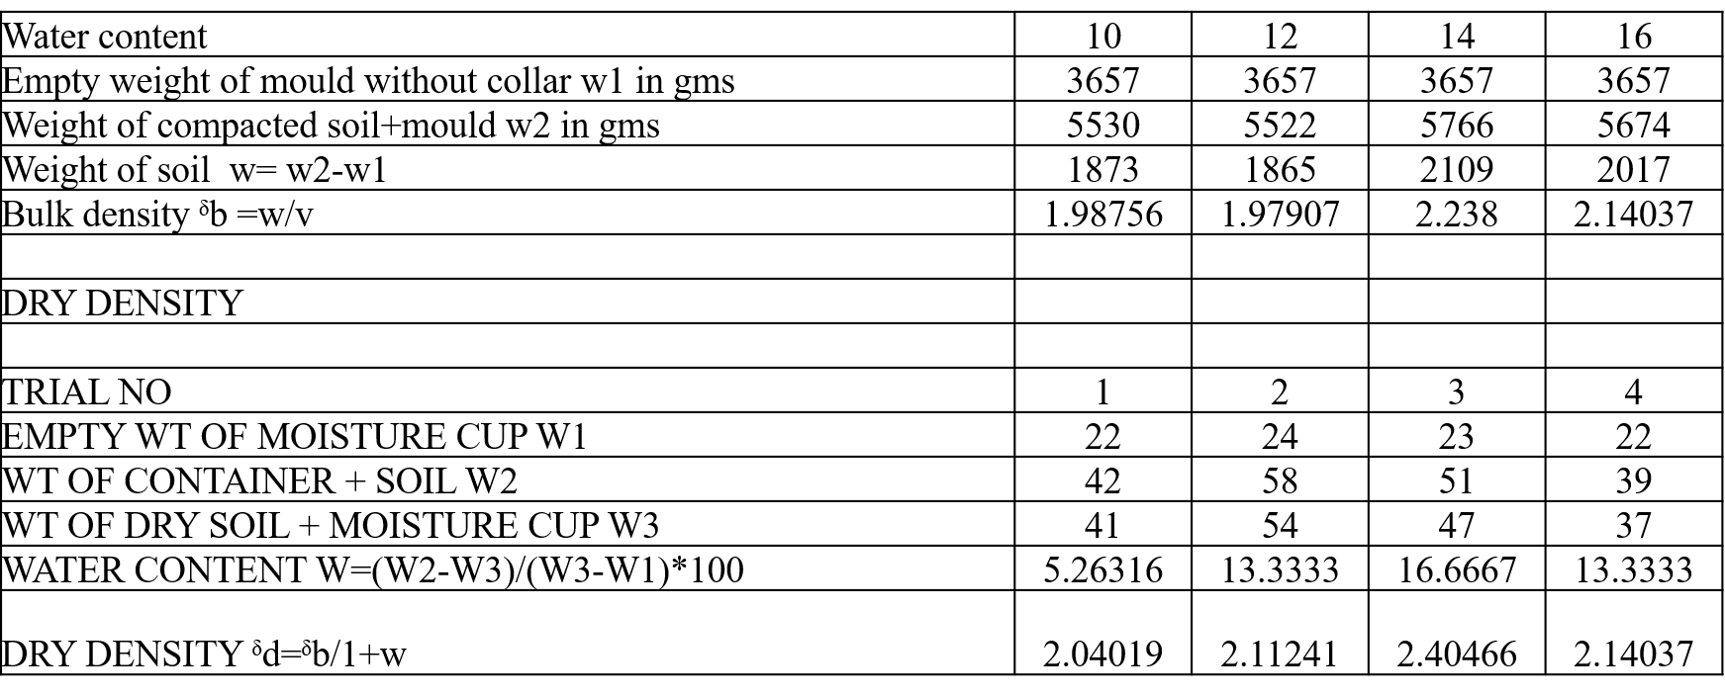

RESULT : OPTIMUM MOISTURE CONTENT = 14%

MAXIMUM DRY DENSITY =2.4g/cc

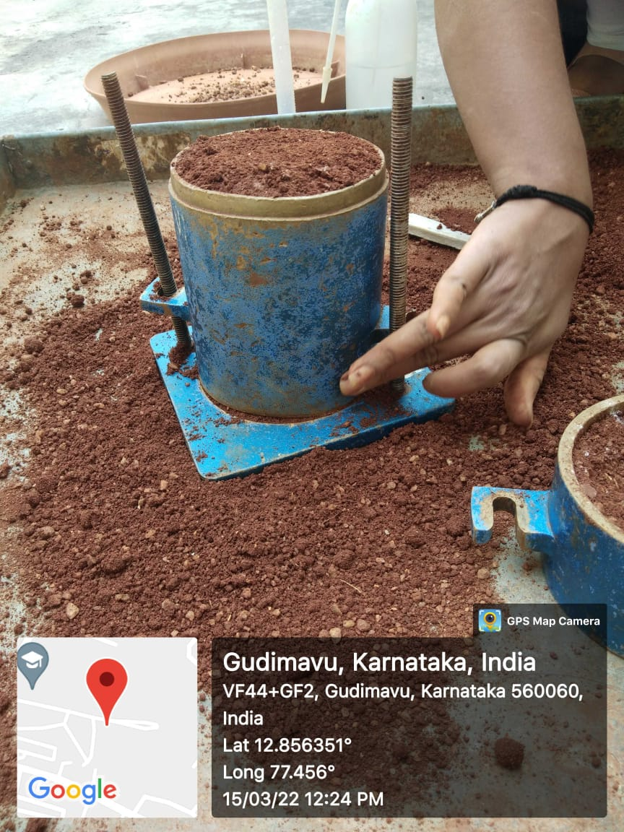

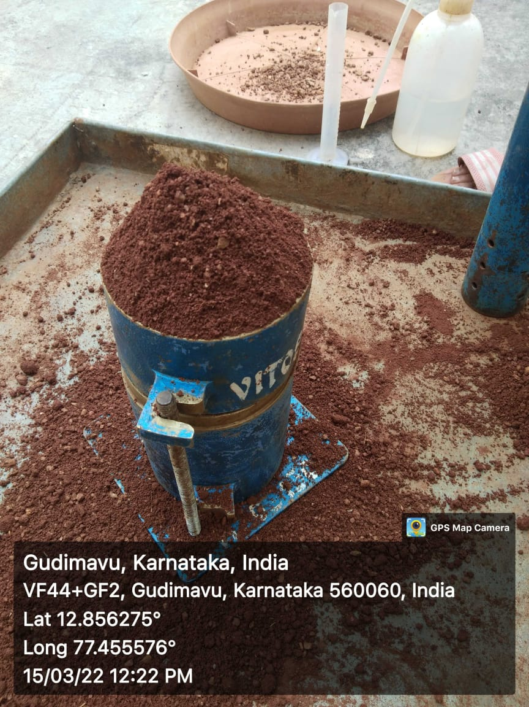

COMPACTION TEST RESULT

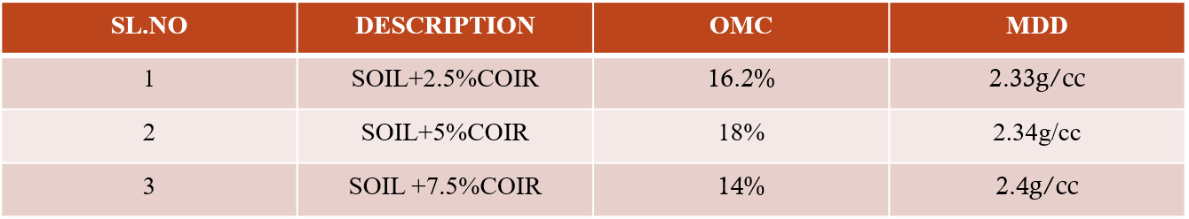

Above this graph indicated the compaction results of variable percentage of coconut coir with an maximum dry density of 2.4g/cc and corresponding of optimum moistyre content 14%

Soil=2800kg

Coir=7.5%

Egg shell=10%

Glass powder=2.5%

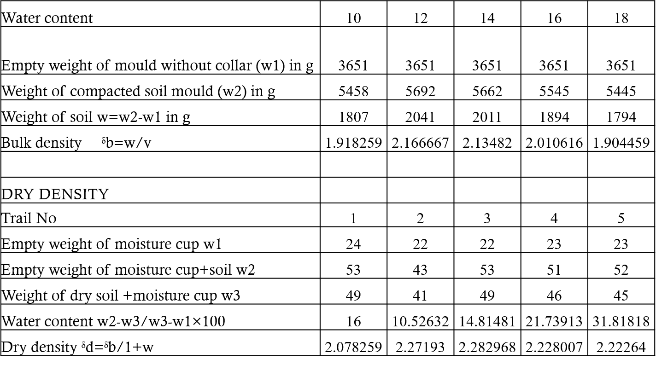

RESULT : OPTIMUM MOISTURE CONTENT = 12%

MAXIMUM DRY DENSITY =2.29g/cc

Soil=2675kg

Coir=7.5%

Egg shell=20%

Glass powder=5%

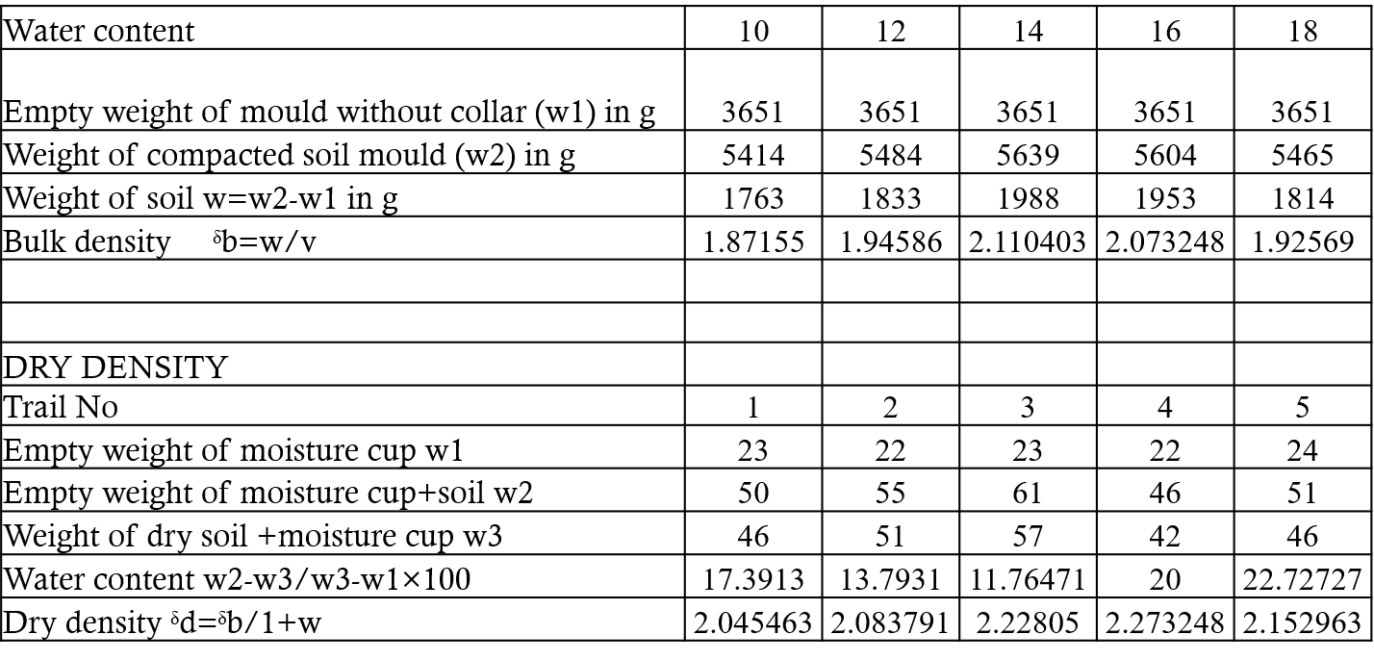

RESULT : OPTIMUM MOISTURE CONTENT = 15.5%

MAXIMUM DRY DENSITY =2.27g/cc

Soil=2550kg

Coir=7.5%

Egg shell=30%

Glass powder=7.5%

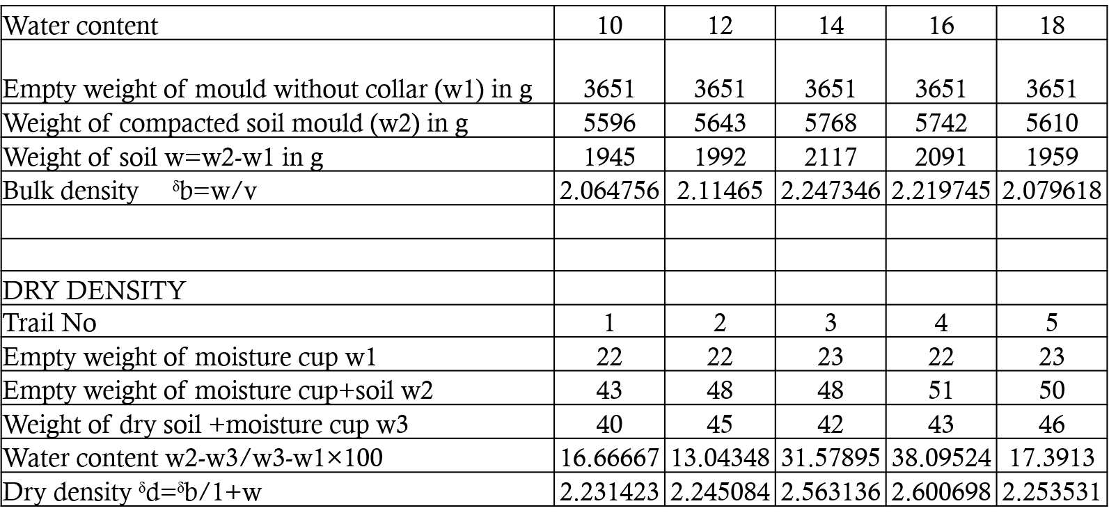

RESULT : OPTIMUM MOISTURE CONTENT = 15%

MAXIMUM DRY DENSITY =2.63g/cc

**COMPACTION TEST RESULTS WITH ADDITIVES**

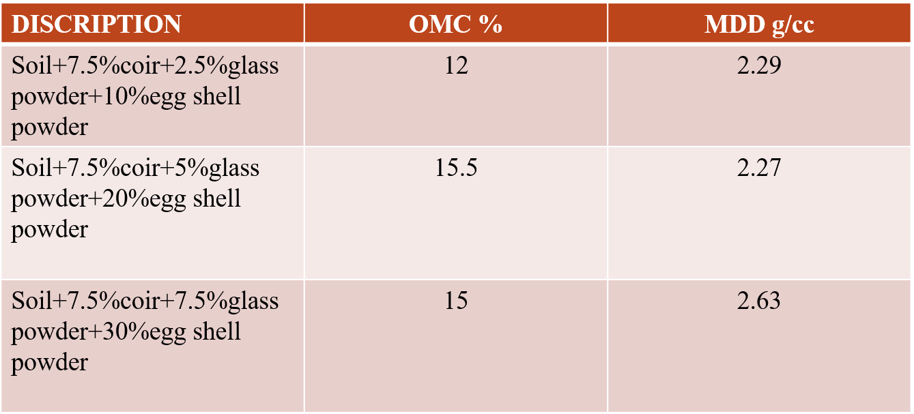

Above table indicates the compaction results of variable percentage

of coconut coir, glass powder, egg shell powder, with maximum

dry density of 2.63 g/cc and corresponding of optimum moisture

content 15%

**METAL MOULD**

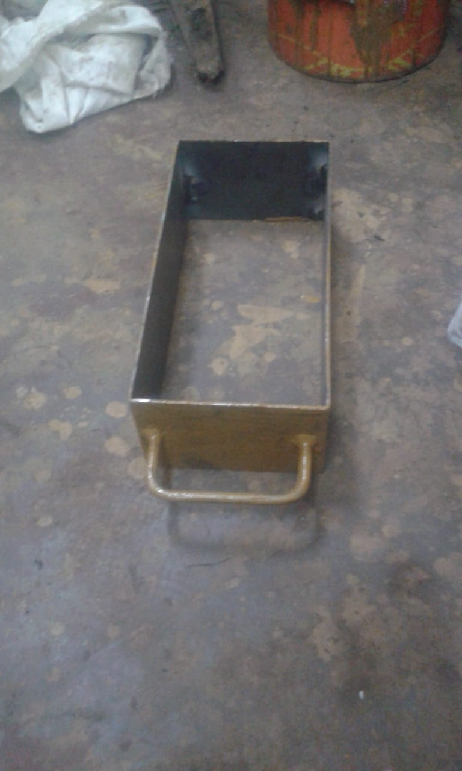

**Size of mould: 230 × 115 × 75mm as per IS 1077:1992**